4.35: a) Motion after he leaves the floor: 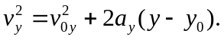
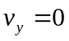 at the maximum height, 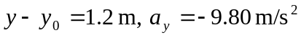, so 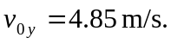
b)
c)
